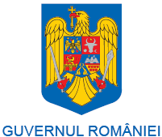 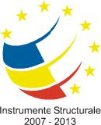

***PROJECT TITLE: AGROTRANSILVANIA CLUSTER – INOVATION CLUSTER SPECIALISED IN THE BIOECONOMY FIELD***

**Crossborder Agri-Food Collaboration – From Farm to Fork**

**(Romanian – Italian B2B)**

**04.04.2016**

* 11.00 - Pick up the Italian delegation from the Cluj *Avram Iancu* International Airport;
* 11:30-12:00 - Check in at the Melody Hotel;
* 12.00-15.00 – Free time to visit the Cluj-Napoca City;
* 16.00-20.00 - AgroTransilvania Cluster presentation at Tailors’ Tower;
  + The activity of AgroTransilvania Cluster –Mr. Felix Arion **PHD**, General Manager (30 min.)
  + Presentation of the new Laboratory for safety and quality control of food products –Mrs. Carmen Socaciu **PHD** / Mr. Marian Mihaiu **PHD** (30 min.);
  + Presentation of Somes Aries Cooperativa Agricola and Taga Dairy Factory – Mr. Andrei Prodan (30 min.);
  + Presentations from the Italian delegation (1 hour);
  + Romanian traditional food tasting and dinner.

**05.04.2016**

* 09.30-11.00 - Visit at **University of Agricultural  Sciences and Veterinary Medicine Cluj-Napoca, meeting with Rector, Mr. Cornel Cătoiu PHD;**
* 11.00-15.00 - Local farms visit (including lunch);
* 16.00-18.00 – Turda Salt Mine visit;
* 19.00-21.00 - Dinner - Crama La Salina, member of AgroTransilvania Cluster.

**06.04.2016**

* 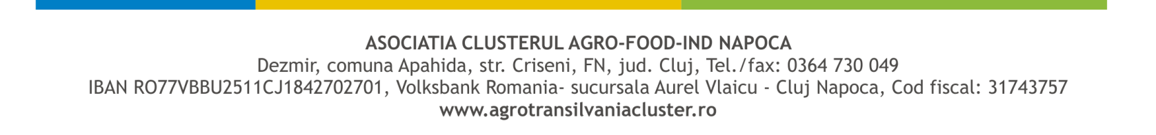05.00 - Transfer of the Italian delegation to the Cluj *Avram Iancu* International Airport.

***Integrator pole for sustainable development of agribusiness sector in Transylvania.***