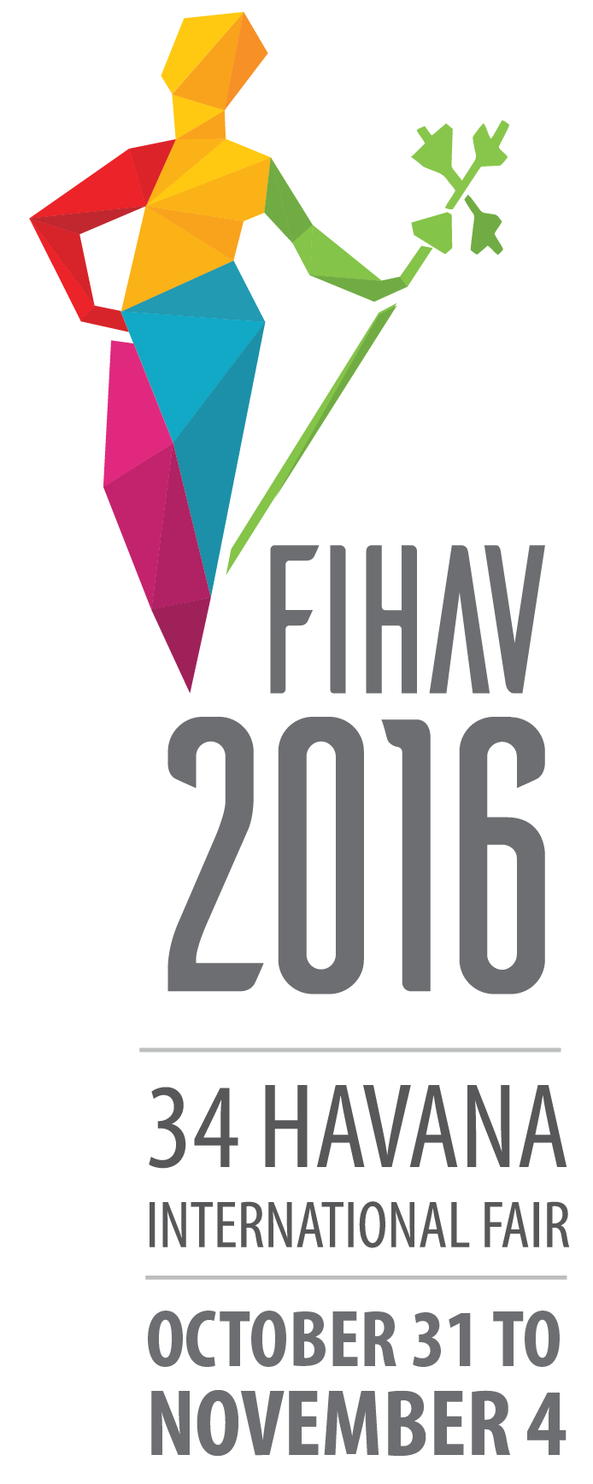

Dear Exhibitors:

On behalf of the Organizing Committee of the Havana International Fair (FIHAV), I take pleasure in inviting you to participate in its 34rd edition, to be held on October 31st - November 4th at Expocuba fairground.

FIHAV is a well-established fair that takes place annually since 1983. It is the most important general trade fair in Cuba and the Caribbean as well as one of the most representative from Latin America.

All sectors of the Cuban economy will take part in this event, which succeeds in putting together the most complete national and international trade exhibition in a space that enables exhibitors and visitors to establish commercial contacts, close business operations, exchange experiences and update in new technological developments. It is also an ideal business platform to know the benefits that Cuba provides for the development of foreign capital and international economic relations, through the new Foreign Investment Law and the establishment of the Special Area Development Mariel.

In its 34rd issue FIHAV will have more than 25,000 m² of net exhibition area, around 4,500 national and foreign exhibitors from over 60 countries, and expects to receive 150,000 visitors and the participation of important foreign official and business delegations, thus consolidating as a way of promoting our country’s international links and relations with the entire world.

You may rely on us for interesting work sessions and unforgettable moments during your stay in Cuba.

We look forward to meeting you at the Fair.

RODRIGO MALMIERCA DÍAZ
Minister of Foreign Trade and Investment
President of the Organizing Committee

Date: October 31st - November 4th, 2016
Schedule hours: 10:00 – 17:00 hrs.
Venue: Expocuba fairground

Organizing Committee

- Ministry of Foreign Trade and Investment
- Chamber of Commerce of the Republic of Cuba
- PALCO Business Group

Categories

FIHAV is a multi-sector trade fair with raw materials, foodstuffs, textiles, consumer goods, machinery and equipment, technology and services as its main areas.

General Program

October 19 – 30  9:00 a.m. – 5:00 p.m. | Mounting of free design stands (accredited personnel with previous coordination with the Organizing Committee)
October 26 – 30  9:00 a.m. – 5:00 p.m. | Accreditation of exhibitors  Mounting of modular stands
October 31  11:00 am. | Opening Ceremony  Plaza de las Banderas, Expocuba
1 – November 4  10:00 a.m. – 5:00 p.m. | Professional Visits
November 4  11:00 – 5:00 p.m. | Admission of general public
November 4  7:00 p.m. | Awarding Ceremony  Palacio de Convenciones de La Habana
November 5  9:00 a.m. – 5:00 p.m. | Withdrawal of samples
November 7 – 12  9:00 a.m. – 5:00 p.m. | Withdrawal of samples and dismounting of stands

The Expocuba fairground is Cuba’s largest exhibition center. It is located on the highway Carretera del Rocío, Km 3 ½, municipality Arroyo Naranjo. It lies some 25 Km southeast of downtown Havana. It has an area of 600,000 m², 25,000 m² of net exhibition area and 25 pavilions for exhibitions.

The participating enterprises are grouped by countries. Depending on the area required, they may have part of a pavilion, an entire pavilion or several pavilions.

Engagement of Exhibition Area

The participation will be made official using the form “Contract Request of Participation” form, to be requested by addressing pabexpo1@palco.cu / luisgutierrez@palco.cu or directly at Pabexpo with deadline September 16.

The “Contract Request of Participation” form will be handed in with the complete information, including stand design. In order to confirm the space reservation and receive his location, the exhibitor will pay 50% of the cost of the hired area at the moment of formalizing his request. The deadline for payment of the remaining 50% of space and engaged services will be 20 days before the opening of the Fair.

In the event that the samples exhibit in Interior Area have large dimensions, weight or other special features, the exhibitor must inform the organizer no less than 20 days before the start of the Fair, for evaluation and approval, attention mounting specifications, coordination for access to the halls and fairgrounds requirements.

Services to Exhibitors at Expocuba

The Organizing Committee offers the following services to the exhibitors:
- Organization of a business round
- Trade information bureau
- Programs of conferences, seminars
- Design, decoration and mounting of stands
- Graphic design
- Power supply
- Customs dispatch, local transport and handling of samples
- Surveillance and security
- Meeting rooms
- Accommodation reservations
- Currency exchange (bank branch)
- Catering
- Medical care
- Stand cleaning
- Parking
- Organization of social activities
- Taxis

Tariffs

- Indoor stand, mounted
Tariff: CUC 110.00/m² (9 m² and more)
Includes: space, aluminum structure, white modular panels (2.42 x 0.95 m), carpet, sign with exhibitor’s name, power consumption up to 500W, cleaning, protection of samples, credentials (according to the rented area) and entry in the official catalogue (up to 10 lines).

- Indoor stand, mounted (mezzanine)
Tariff: CUC 100.00/m² (9 m² and more)
Includes: space, aluminum structure, white modular panels (2.42 x 0.95 m), carpet, sign with exhibitor’s name, power consumption up to 500W, cleaning, protection of samples, credentials (according to the rented area) and entry in the official catalogue (up to 10 lines).

- Indoor stand, not mounted
Tariff: CUC 100.00/m² (21 m² and more)
Includes: space, carpet, power consumption up to 500W, cleaning, protection of samples, credentials (according to the rented area) and entry in the official catalogue (up to 10 lines)

- Indoor stand, not mounted (mezzanine)
Tariff: CUC 90.00/m² (21 m² and more)
Includes: space, carpet, power consumption up to 500W, cleaning, protection of samples, credentials (according to the rented area) and entry in the official catalogue (up to 10 lines)

- Indoor stand, not mounted (with Special Mounts)
Tariff: CUC 150.00/m² (21 m² and more)
Includes: space, carpet, power consumption up to 500W, cleaning, protection of samples, credentials (according to the rented area) and entry in the official catalogue (up to 10 lines)

Outdoor space

Tariff: CUC 60.00/m² (9 m² and more)
Includes: space, power consumption up to 500W, cleaning, protection of samples, credentials (according to the rented area) and entry in the official catalogue (up to 10 lines).

Professional Visitors

Tariff: CUC 100.00
This fee includes: credentials, trade contacts, official catalogue, participation in official activities, etc.
You may register online in our web site www.feriahavana.com; directly at Pabexpo’s Department of Finances or to your arrival to the Expocuba fairground in the located VIP hall in the Central Pavilion.

How to Pay?

All tariffs are expressed in Cuban convertible pesos (CUC); therefore, the exhibitor must obtain information about the rate exchanges in force in Cuba. Payments in U.S. dollars will not be accepted.

- Address your bank transfers and check to:
Holder: Empresa Organizadora de Congresos, Ferias y Exposiciones
Account number: 0300000004714029
Name of bank: Banco Financiero Internacional BFI
Bank address: Ave. 5ta. Esq. a 92, Playa
Code: SWIFT: BFICCUHH

- Payments in cash or with travel checks, in Cuban convertible pesos (CUC) or with credit cards (Visa International, MasterCard, Cabal or BFI) will be made directly at Pabexpo’s Department of Finances. Once the mounting stage has begun you may address Pavilion 8-A in Expocuba.

Samples for Exhibition at FIHAV

Agencia Transitaria PALCO is the official FIHAV forwarding and customs dispatch agency.

All information concerning arrival terms of goods, and documents required for customs dispatch may be obtained from:

Agencia Transitaria PALCO
Apartado Postal 16046, La Habana, Cuba
Telephones: (53) 7208 3669
E-mail: lianet@dirlog.palco.cu

Most Important Dates for the Exhibitor

Deadline September 16
- Presentation of the “Contract Request of Participation” form.
- Payment of 50 percent of the engaged space.
- Presentation of the free design stand project.
- Reception of the artwork for advertising (PDF format, 16 x 22 cm).

Deadline October 7
- Presentation of the information Official Fair Catalogue.

Deadline October 12
- Payment of the remaining 50 per cent of space and engaged services.
- Report samples to expose whit large dimensions, weight or other special features.
- Arrival of goods by sea.

Deadline October 21
- Arrival of goods by air.

Deadline October 31
- Application for participation in the prizes to the quality of products, design and advertising.

For more information on participation conditions, please consult the Exhibitors’ Manual at http://www.feriahavana.com or request it at pabexpo1@palco.cu / luisgutierrez@palco.cu or by phone (53) / 7271-6614 / 7271-5513 / 7271-3670.

