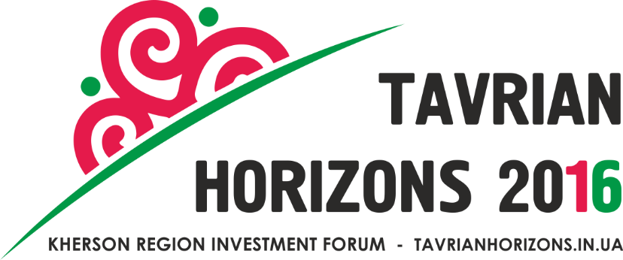

IX INTERNATIONAL INVESTMENT FORUM

«TAVRIAN HORIZONS: cooperation, investments, economic development»

Organizers:
Kherson Regional State Administration
Kherson Regional Council
USAID Leadership in Economic Governance (LEV) Program
30/09/16 – 01/10/16 | Cultural-entertainment complex "Premier"  Nova Kakhovka (Kherson region)  Dniprovsky avenue, 42

September, 30 (Friday)*
Exposition of Kherson region brand manufacturers

9.00 – 10.15 | Registration of the Forum participants, welcome coffee
 | Gala session
10.30 | The opening ceremony  Welcome speeches of the:  - Head of Kherson regional state administration Andrii Gordieiev  - Head of the Kherson regional Council Andrii Putilov  - Prime Minister of Ukraine Volodymyr Groysman  - Chairman of the International trade club in Ukraine Mr. Andras Kadar  - President of East Europe Foundation Mr. Victor Liakh  - Program Director USAID Leadership in Economic Governance (LEV) Mrs. Tamara Solyanyk
11.00 | Presentation of the potential of the Kherson region  «Kherson Region – Synergy of Prospects»
Opportunities of high-capacity transport hub of Ukraine through transport logistics development
Speaker: Hero of Ukraine, General Director of the LLC AE NIBULON, Oleksiy Vadaturskii
Kherson Region – the territory of energy efficient technologies
Speaker: acting deputy head of Kherson Regional State Administration Oleksander Adamchyk
Development of modern hotel-resort industry - Kherson Region tourism driver
Speaker: Honorary President of the LLC «Morski vorota», Honorary Consul of the Kingdom of Sweden Carl Sturen
Industrial parks of the Kherson Region – regional economic growth points
Speaker: Chairman of the board LLC RPE “Kherson machine building plant”, Oleksandr Oleinyk

12.30 | Signing of cooperation memorandums
12.45 – 13.20 | Press conference for mass media
12.45 – 14.00 | Lunch
13.45 – 15.00 | Bilateral meetings with members of the International trade club (heads of trade-economic departments of embassies of Poland, Austria, Belgium, Germany, Slovakia) in B2B format
14.00 – 17.00 | Business discussion platform
- Panel discussion: «Kherson region – tourist pearl of Ukraine – synergy of nature and hospitality»
Moderator: Ivan Liptuga, director of the Department of tourism and resorts of the Ministry of economic development and trade of Ukraine
- Panel discussion: «Investments in agribusiness»
Moderator: Andrii Stefanovych, director of the Department scientific and educational providing and rural entrepreneurship development of The Ministry of agrarian policy and food of Ukraine
- Panel discussion: «Industry, transport infrastructure, energy efficiency and their investment attractiveness»
Moderator: Pavlo Sheremeta, Director of School of Public Management under Ukrainian Catholic University, former Minister of economic development and trade of Ukraine
- Roundtable: «Developed business-climate – the basis for investment attraction»
Moderator: Igor Burakovky, Senior Adviser of USAID Leadership in Economic Governance (LEV) Program, Head of the Board of The Institute for Economic Research and Policy Consulting
5.Panel discussion: «Economically able communities of Kherson region –guarantee of the regional development»
Moderator: Anatolii Tkachuk, director on science and development issues of Public Organization "Institute of Civil Society"
18.00 | Reception from the Head of the Regional State Administration Andrii Gordieiev

October, 01 (Saturday)**

9.00 – 15.00 | Presentation and acquaintance of Forum participants with production capacities, investment proposals and areas of Kherson region according to the following spheres:  - Agrarian sector – opportunities for the full production cycle;  - Industry – brownfields and territories for your technologies development;  - Transport hub – marine and air gateway of Ukraine;  - Tourist pearl of Ukraine – synergy of nature and hospitality of Kherson citizens  Excursion among tourist sites of Kherson region (Biosphere reserve Askania-Nova of F.E.Falz-Fein)

* -Along with Forum activity the IT-hackathons (green-zone) will be held as well as the fam-trips for tour operators from Italy, Germany and Ukraine.
** - Tavrian regional business-day.

There may be made changes in the program. Please, follow us on tavrianhorizons.in.ua
Organizers: Kherson Regional State Administration,
Kherson Regional Council
USAID Leadership in Economic Governance (LEV) Program
The Department of investments, tourist activities and industrial policy
+38 (0552) 22-57-68, 26-22-56, e-mail: info@tavrianhorizons.in.ua

