TOV “Ukrainian Solutions”
04119, Ukraine, Kyiv, Melnikova str., 36 info@ukrainiansolutions.com
Enterprise code 41341426
tel. +380632842267, +380988124097

Commercial offer

Dear Partners! We are glad to represent the State Enterprise "Zhytomyr Liquor and Vodka Distillery Factory" which is one of the oldest manufacturing companies in Ukraine, founded in 1896, it expresses you respect and offers cooperation and partnership in building distribution and promotion of alcoholic beverages.

Today Zhytomyr Liquor and Vodka Distillery Factory is a state enterprise that produces 52 kinds of alcoholic beverages, namely “Zhytomyr Vodka on Buds”, “Staryi Zhytomyr Vodka. Renewed”, “ Zhytomyr Standard Vodka”, “Chudnoff”, “ Presidential Standard Vodka”, “Teteriv” , “Zubrovka”, “Bester”, “Ambra Vita”.

Zhytomyr Liquor and Vodka Distillery Factory’s vodka and tinctures are famous for pleasant taste, aroma and amazing softness and ease. This is the result of the careful preservation of old recipes and new developments of copyright prescription, using only natural ingredients and strict quality control at all stages of production. Grain alcohol, sweet honey, fruits and berries, herbs are the parts of a rich and a generous Ukrainian land and have been used in original recipes of the factory. So, natural product is a quality product, high quality and originality are the main criteria of our success. Factory products were observed repeatedly in national and international competitions, exhibitions and tastings.
Payment conditions - 100% prepayment, prices are set under conditions of FCA – Zhytomyr city.

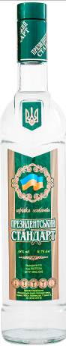 | Special vodka “ Presidential Standard”  Alcohol content: 38 % by vol.  Glass bottles: 0.75 l  Price: 1.74 $ / 1.62 €
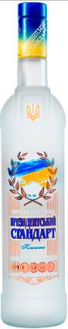 | Special vodka “ Presidential Standard Classic”  Alcohol content: 40 % by vol.  Glass bottles: 0.75 l  Price: 2.24 $ / 2.08 €
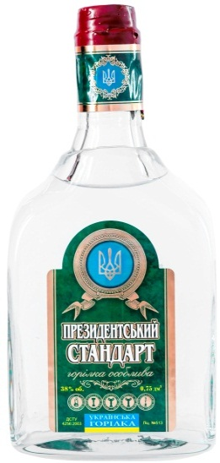 | Special vodka “ Presidential Standard” shtof  Alcohol content: 38 % by vol.  Glass bottles: 0.75 l  Price: 5.19 $ / 4.83 €
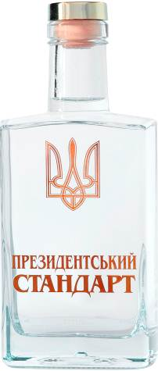 | Special vodka “ Presidential Standard” decorated bottle  Alcohol content: 38 % by vol.  Glass bottles: 0.5 l  Price: 3.19 $ / 2.97 €

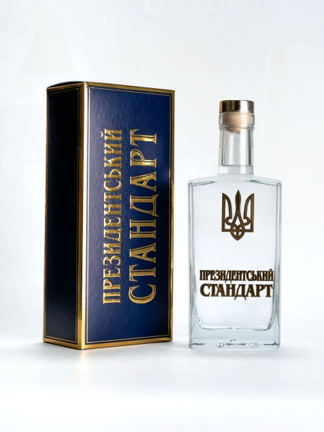 | Special vodka “ Presidential Standard” decorated bottle in box  Alcohol content: 38 % by vol.  Glass bottles: 0.5 l  Price: 3.79 $ / 3.52 €
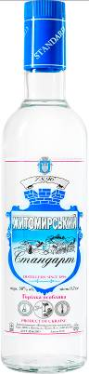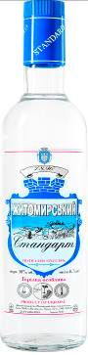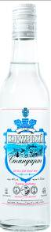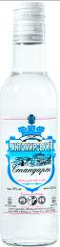 | Special vodka “ Zhytomyr Standard “  Alcohol content: 38 % by vol.  Glass bottles: 0.25 l , 0.375 l , 0.5 l , 0.7 l  Price: 0.25 l - 0.54 $ / 0.50 €  0.375 l - 0.74 $ / 0.69 €  0.5 l – 1.04 $ / 0.97 €  0.7 l – 1.33 $ / 1.24 €
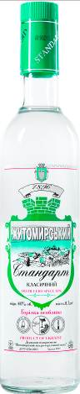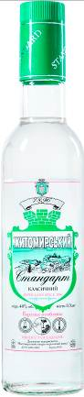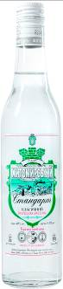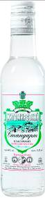 | Special vodka “ Zhytomyr Standard Classic “  Alcohol content: 40 % by vol.  Glass bottles: 0.25 l , 0.375 l , 0.5 l , 0.7 l  Price: 0.25 l - 0.54 $ / 0.50 €  0.375 l - 0.74 $ / 0.69 €  0.5 l – 1.04 $ / 0.97 €  0.7 l – 1.33 $ / 1.24 €
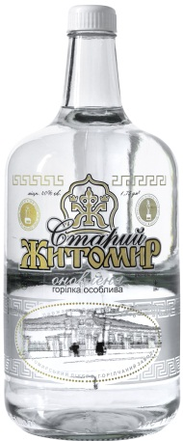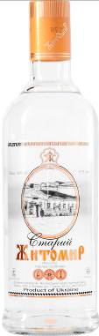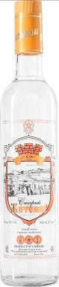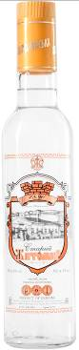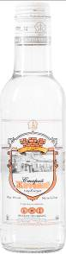 | Special vodka “Stariy Zhytomyr. Renewed “  Alcohol content: 40 % by vol.  Glass bottles: 0.25 l , 0.5 l , 0,375 l, 0.7 l , 1.75 l  Price: 0.25 l - 0.54 $ / 0.50 €  0.375 l - 0.74 $ / 0.69 €  0.5 l – 1.04 $ / 0.97 €  0.7 l – 1.33 $ / 1.24 €  1.75 l – 3.19 $ / 2.97 €

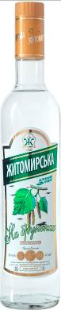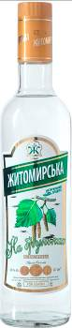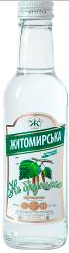 | Special vodka “ Zhytomyr Сlassic on Birch Buds”  Alcohol content: 40 % by vol.  Glass bottles: 0.25 l , 0.5 l , 0.7 l  Price: 0.25 l - 0.54 $ / 0.50 €  0.5 l – 1.04 $ / 0.97 €  0.7 l – 1.33 $ / 1.24 €
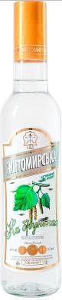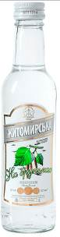 | Special vodka “ Zhytomyr Silver on Birch Buds”  Alcohol content: 38 % by vol.  Glass bottles: 0.25 l , 0.5 l  Price: 0.25 l - 0.54 $ / 0.50 €  0.5 l – 1.04 $ / 0.97 €
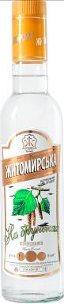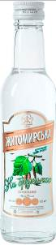 | Special vodka “ Zhytomyr Gold on Birch Buds”  Alcohol content: 40 % by vol.  Glass bottles: 0.25 l , 0.5 l  Price: 0.25 l - 0.54 $ / 0.50 €  0.5 l – 1.04 $ / 0.97 €
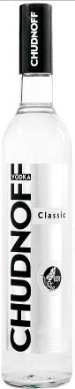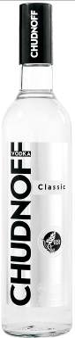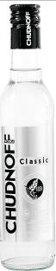 | Special vodka “Chudnoff”  Alcohol content: 40 % by vol.  Glass bottles: 0.25 l , 0.5 l , 0.7 l  Price: 0.25 l - 0.54 $ / 0.50 €  0.5 l – 1.04 $ / 0.97 €  0.7 l – 1.33 $ / 1.24 €

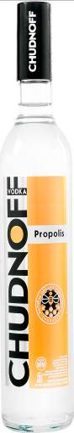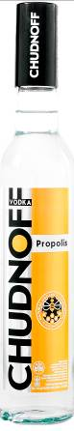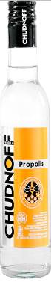 | Special vodka “Chudnoff. Propolis”  Alcohol content: 38 % by vol.  Glass bottles: 0.25 l , 0.5 l , 0.7 l  Price: 0.25 l - 0.54 $ / 0.50 €  0.5 l – 1.04 $ / 0.97 €  0.7 l – 1.33 $ / 1.24 €
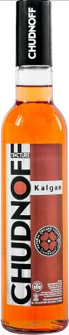 | Tincture “Chudnoff. Kalgan”  Alcohol content: 40 % by vol.  Glass bottles: 0.5 l  Price : 0.5 l – 1.04 $ / 0.97 €
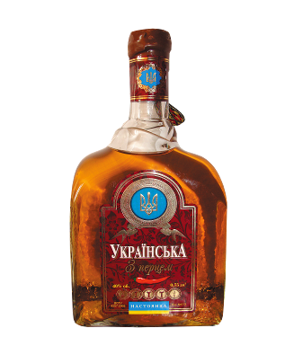 | Tincture “Ukrainian with pepper” shtof  Alcohol content: 40 % by vol.  Glass bottles: 0.75 l  Price : 0.75 l – 5.19 $ / 4.83 €
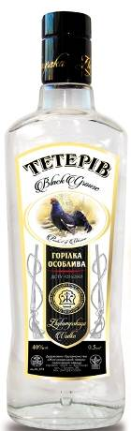 | Special vodka “Teteriv”  Alcohol content: 40 % by vol.  Glass bottles: 0.2l, 0.5 l, 0.7 l. 1l  Price: 0.2 l - 0.44 $ / 0.41 €  0.5 l – 1.04 $ / 0.97 €  0.7 l – 1.33 $ / 1.24 €  1.0 l – 1.79 $ / 1.66 €

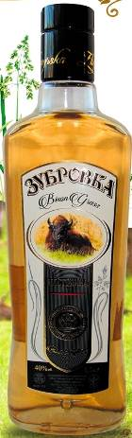 | Tincture “Zubrovka”  Alcohol content: 40 % by vol.  Glass bottles: 0.2 l , 0.5 l  Price: 0.2 l - 0.44 $ / 0.41 €  0.5 l – 1.04 $ / 0.97 €
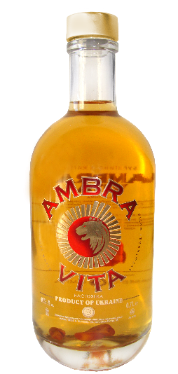 | Tincture «Amber Life» (« AMBRA VITA»)  Alcohol content: 40 % by vol.  Glass bottles: 0.7 l  Price: 7,23 $/ 6.72 €
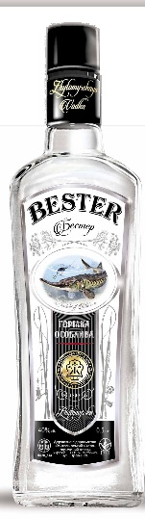 | Special vodka “BESTER”  Alcohol content: 40 % by vol.  Glass bottles: 1.0 l  Price: 1.0 l – 1.74 $ / 1.62 €

