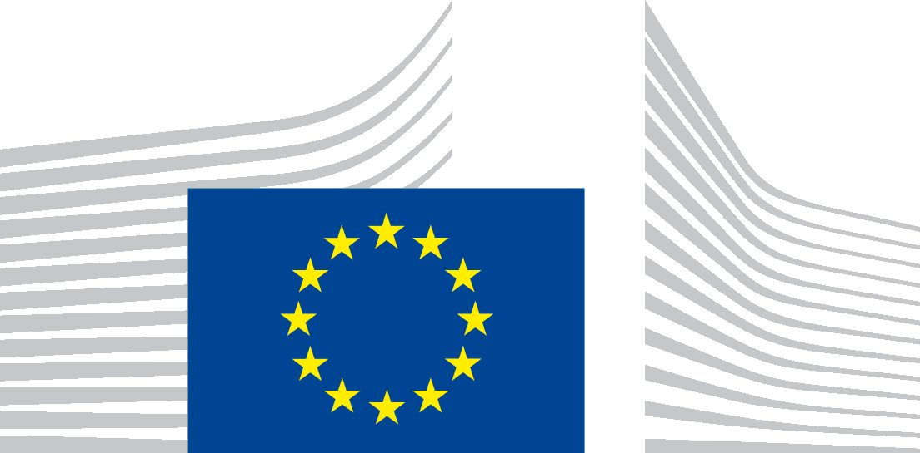 | EUROPEAN COMMISSION  Directorate-General for Internal Market, Industry, Entrepreneurship and SMEs  Industrial Transformation and Advanced Value Chains  Director
Brussels,

Invitation to a Conference on the Construction & Demolition Waste Management Protocol

European Commission Representation in Romania
Str. Vasile Lascăr, Nr. 31, București

17 October 2017

Dear Madam, Dear Sir,
Construction and Demolition (“C&D”) waste represents both a risk and an opportunity for the environment and real challenges for the European Union. A large majority of Construction & Demolition Waste (CDW) is recyclable but the average recovery rate for the EU28 is below 50%. Yet, the Waste Framework Directive http://eur-lex.europa.eu/legal-content/HR/TXT/?qid=1494245311751&uri=CELEX%3A32008L0098 has established the target for 70% of Construction & Demolition Waste to be recycled by 2020.
To turn this mountain of waste into an economic, environmental and social opportunity, experts from the industry and the European Commission have drawn up the EU Construction and Demolition Waste Management Protocol http://ec.europa.eu/DocsRoom/documents/20509/attachments/1/translations/. The guidelines support the material and product quality that will generate trust throughout the C&D waste management chain and provide benefits from demolition to reclamation and value added transformation. This €7.5 billion pan-European market is within reach with huge impacts, including the creation of thousands of qualified jobs.
We invite you to participate in the morning workshop being held in Bucharest on 17 October 2017. The European Commission will present the Protocol, and the event will bring together stakeholders from the sector to share best practice as well as opportunities. Your attendance is important to the discussion on the day, and please do stay for the sandwich lunch provided to network with like-minded professionals.
Please register your interest at https://ec.europa.eu/eusurvey/runner/CDWRoadshowBucharest17Oct17. The European Commission cannot reimburse any expenses incurred.
The aim of this conference is to inspire you for taking up this opportunity for sustainable growth of the Construction & Demolition waste sector. We look forward to welcoming you.
Yours sincerely,
Gwenole Cozigou
Director

