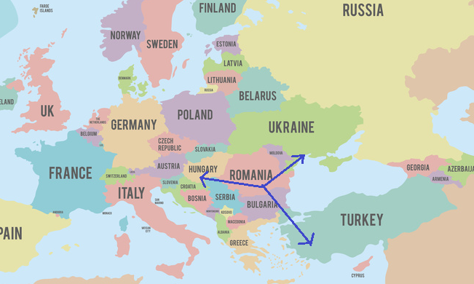

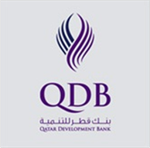
QATAR MISSION TO ROMANIA
30TH – 31ST OCTOBER 2017

AGENDA

Monday 30th of October
Venue: Constanta Ballroom / JW Marriott Bucharest Grand Hotel
Address: Calea 13 Septembrie 90, Bucharest

Registration: 8 AM to 9 AM

9:00 – 9:10: Introduction
Welcome Speech by Georgeta Argesanu, acceleRO International Development
and Cristina Cocirla - Head of Promotion and Marketing Foreign Investment, InvestRomania,

9:10 – 9:20: QDB Speech
Abdulaziz Nasser Al Khalifa , CEO of QDB

9:20 – 9:30: Qatar Ambassador Speech
H.E. Abdullah Bin Nasser Al-Humaidi

9:30 – 9:50: Welcome address by Chamber of Commerce and Industry of Romania (Panel discussion)
Mihai Daraban, President of the Chamber of Commerce and Industry of Romania (TBC)

9:50 – 10:30 Why Romania – Business Opportunities and Market,
Georgeta Argesanu – acceleRO International Development
Business Lawyer and Financial Expert – speakers to be confirmed

10:30 – 10:40 Introduce Qatari Companies

10:40 - 11:00 Coffee Break

11:00 – 13:00 Business to Business Meetings

13:00 – 14:00 Lunch

14.00 – 16.00 Business to Business meetings

Tuesday 31st of October

10.00 - 16.00 Business to Business meetings

Eveniment organizat cu sprijinul

