

Dear Sir

We would like to introduce our group to your appreciated company:

**Al Doha Company For Food Stuff**

We are a FMCG Manufacture Group based in Egypt that focus on sourcing products globally for all major chain groups all over the world. We are dedicated to our business, our people and our partners and will start off with growing your business.

**Al Doha Company For Food Stuff’s** services support every level of business, assisting in strategic development, marketing, distribution and brand management. Egypt is one of the most sophisticated, diverse and promising emerging markets in the world. Strategically located at the top of the African continent, Egypt is a key investment location, both for the commercial opportunities within its borders and the potential it offers as a gateway to the rest of the continent. Egypt has enormous potential as an investment destination: a unique combination of highly developed first-world economic infrastructure with a vibrant emerging market economy. Egypt also has the resident marketing skills and distribution channels to open up commercial ventures into the rest of Africa and all over the world.

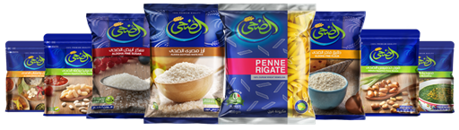

At **Al Doha Company for Food Stuff**, we take great care to research and develop only reliable, quality products that create high and consistent repeat sales and encourage brand loyalty.

All our products undergo stringent safety certification before being launched to market.

Our FMCG products are widely recognized as premium products which equal or surpass the performance of other established high profile brands.

We are dealing, trading and exporting consumer goods that provide a value price for the consumer and excellent margins for the B2B wholesaler with no intermediary agents to dilute profits.

**Al Doha Company for Food Stuff** confident that you will find our products especially innovative and our prices respectable, and hope that our many years of experience in providing an excellent service will surpass your expectations on every occasion. Each of our products have been independently tested and approved to be amongst the best products available on the market. Copies of tests and indeed certificates are readily available at request. Powerful in-store marketing individually supports the complete range of brands, and is re-enforced by individual websites and literature. Our launch spans Europe, the USA, Far East, central and southern Africa.

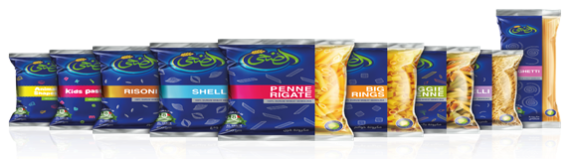

Finally as members of numerous professional bodies and associations, we have made a conscious effort to raise the profile of all our products. Whether it is through heavy in-store marketing, stock promotion and give away or support for global causes, we are certain that stockiest will make volume sales and of course maximize their profits.

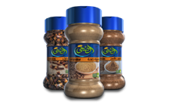

For years, the company’s unchanged strategy has been to build brands that are deeply rooted in consumer consciousness and to accomplish projects of acquisition that may expand and develop its range of brand products.

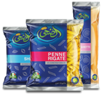

**Al Doha Company For Food Stuff** provide a dedicated and professional service which maximizes the potential of your residual inventory, providing a web of distribution bringing together small fragmented markets, we create a supply chain link to emerging retail outlets that enables your brands to reach new consumers.

Arab Investors Trade Company have over 20 years’ experience in the safe and discreet distribution of residual inventory within the secondary channel, acting as an extension of your sales division to help overcome the challenges of distributing to a rapidly growing sector.

Our expertise and proven business model have enabled **Al Doha Company For Food Stuff** to work with ALL of the world’s leading FMCG Multinational manufacturers.

We have a dedicated team of industry professionals with unrivalled acumen, our executives are from multicultural backgrounds with industry experience across 5 continents.

We pride ourselves on our honest and reputable approach, we have a strict ethic of transparency, providing clear lines of communication with no ambiguity.

Protecting the reputation of your brands is at the heart of our business and every decision made within our organization echo’s this statement.

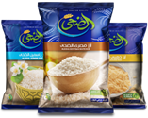

**We will be very pleased to start our business co-operation with your appreciated company in (Win-Win) relation business ship. Benefits for each of our companies.**

**OUR COMPLETE COMPANY PROFILE LINK :**

[**https://drive.google.com/drive/folders/0BwMJghNC1ovUX20tcjJFT2lqblk**](https://drive.google.com/drive/folders/0BwMJghNC1ovUX20tcjJFT2lqblk)

 Be waiting all your comments and feedback.

**Thanks & Best regards.**

**Hatem Nassar**

**Export Director**

**Al Doha Group for Food Stuffs Co.**



**E-mail:** [**export@eldoha.com**](mailto:export@eldoha.com)

**Mob.: +201282100616**

**Tel : +2 0227565344-46**

**Fax: +2 0227565345**

**Hot Line : 19589**

**Industrial Zone C4**

**10th  Ramdan City ,  Egypt**

  Description: Description: نتيجة بحث الصور عن ‪iso food certification labels‬‏ 

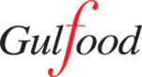

**18 - 22 FEBRUARY 2018**

**DUBAI WORLD TRADE CENTRE**

**#GULFOOD**