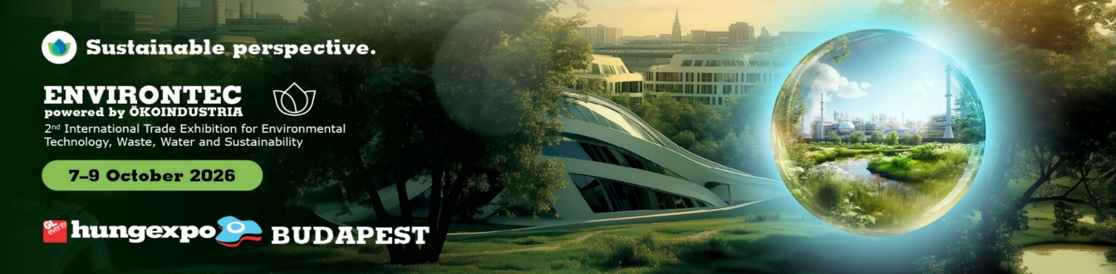

From 7–9 October 2026, ENVIRONTEC powered by ÖKOINDUSTRIA International Trade Exhibition for Environmental Technology, Waste, Water and Sustainability reopens in Budapest as one of Hungary’s and the region’s leading international trade fairs and business forums for environmental industries.
The event serves as a key meeting point for the green industry, bringing together decision-makers, investors, environmental and sustainability-focused companies, researchers, technology developers, and industrial users to connect, exchange knowledge, and shape the solutions of a more sustainable future.
Main patron: Mr. László Gajdos, Minister, Ministry of the Living Environment
Guest Country: Czech Republic
ENVIRONTEC is more than a trade fair - it is a business, professional and innovation platform where environmental challenges meet practical technologies, strategic partnerships, and new business opportunities.
Key Sectors:
• Circular economy and waste management
• Water management and wastewater treatment
• Remediation and brownfield investments
• Air quality protection
• Noise and vibration control
• Energy efficiency and renewable energy
• Sustainable cities and infrastructure development
• Surface water protection
• Eco-innovations and startups in Central and Eastern Europe
• Environmental consultancy, measurement and sampling
Conference Programme:
• Regulatory changes affecting industrial emissions (IED 2.0)
• A water-smart future? Water-conscious responses and solutions in the era of climate change
• Future of landfilling
• Remediation technologies and emerging trends
• Business opportunities in the Western Balkans

Co-organiser and professional partner: Hungarian Association of Environmental Enterprises(HAEE)
Key professional partner is Hungarian Water Association (HWA)

For more information, visit ENVIRONTEC 2026 website.
Hungarian Association of Environmental Enterprises Contact:
Anna Istenes, email: istenes.anna@kszgysz.hu mobile: +36 30 867 8185

